**Solution 1:**

**Git is installed**

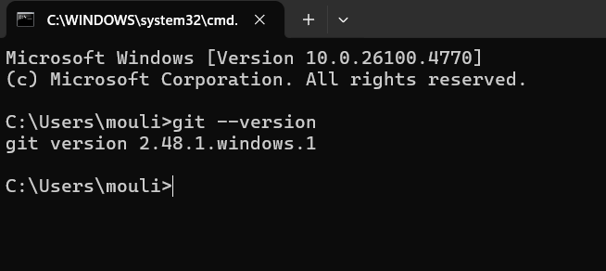

I already configured git 3 years ago

**Verify the configuration**

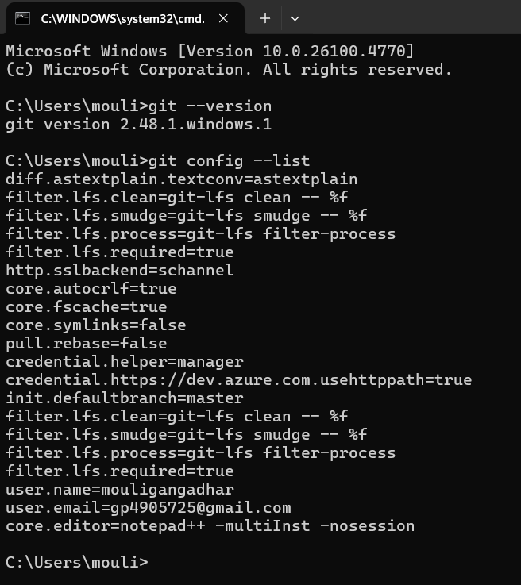

**Configure Notepad++ as Default Git Editor**

git config --global core.editor "notepad++ -multiInst -nosession"

**Verify the editor setting**

git config --global -e

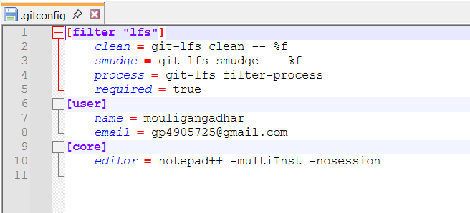

I pull the repo from gitlab to local system using the command “**git pull origin master”**

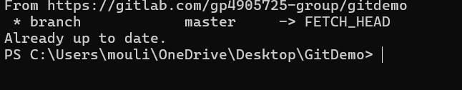

I push the files from the local system to Gitlab repos “ **git push origin master”**

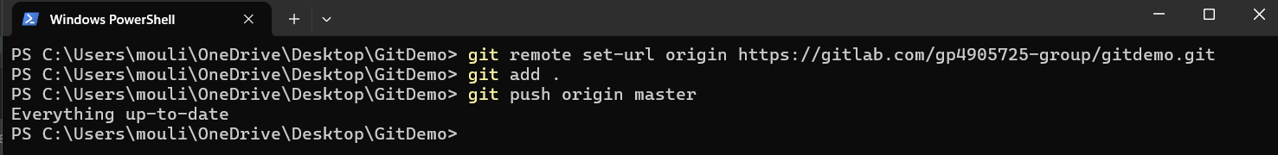

**Result:**

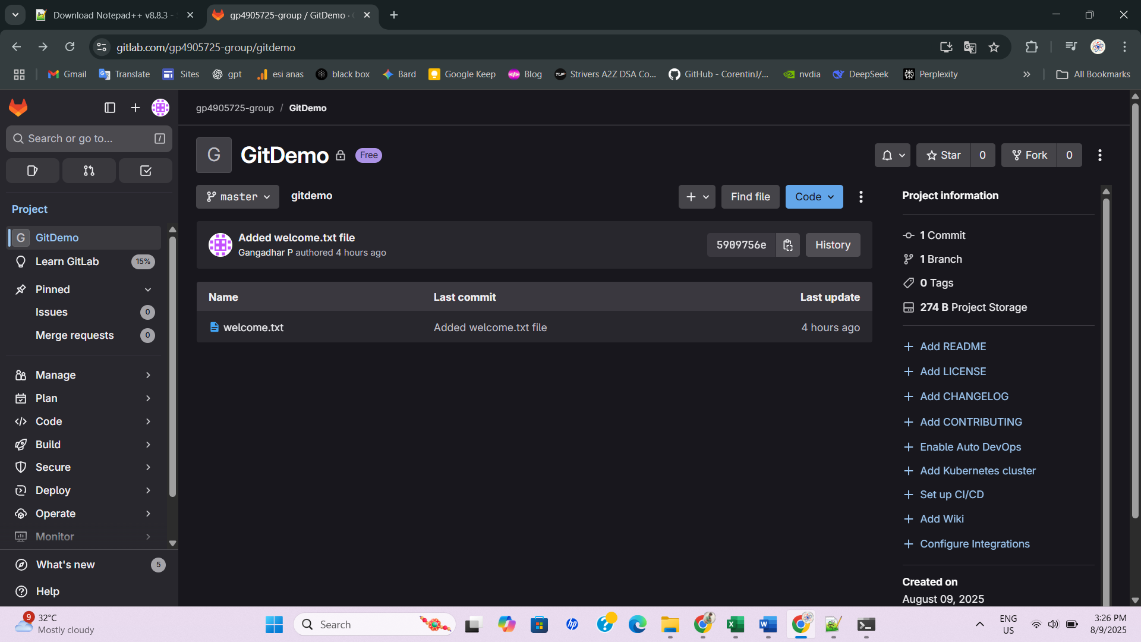

**Solution 2:**

**In this hands-on lab, you will learn how to:**

**Implement git ignore command to ignore unwanted files and folders**

I added the 1 file and 1 directory, these are test.log and log/ in the above first solution gitdemo repository. Im using this commands in CLI

**echo "Sample log data" > test.log**

**mkdir logs**

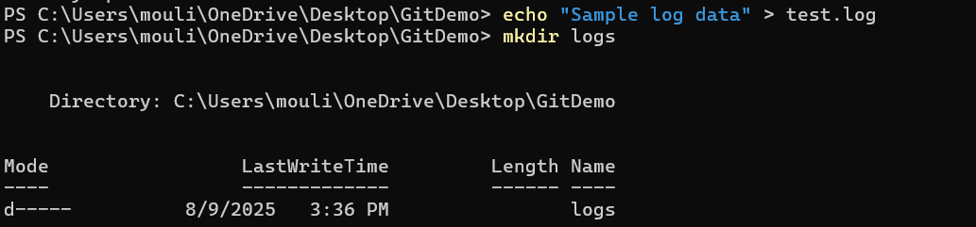

After than I create the .gitignore file inside the gitdemo repository using th notepad++

The command i used for this “**notepad++ .gitignore”**

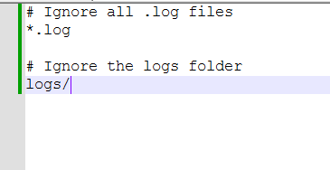

It ignores the all the .log extension files and whole log dir while im push the code into gitlab or github

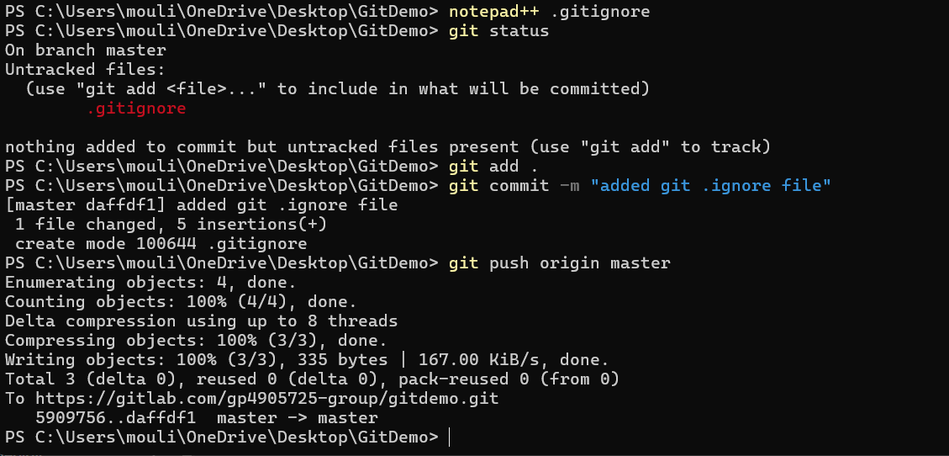

**Result**:

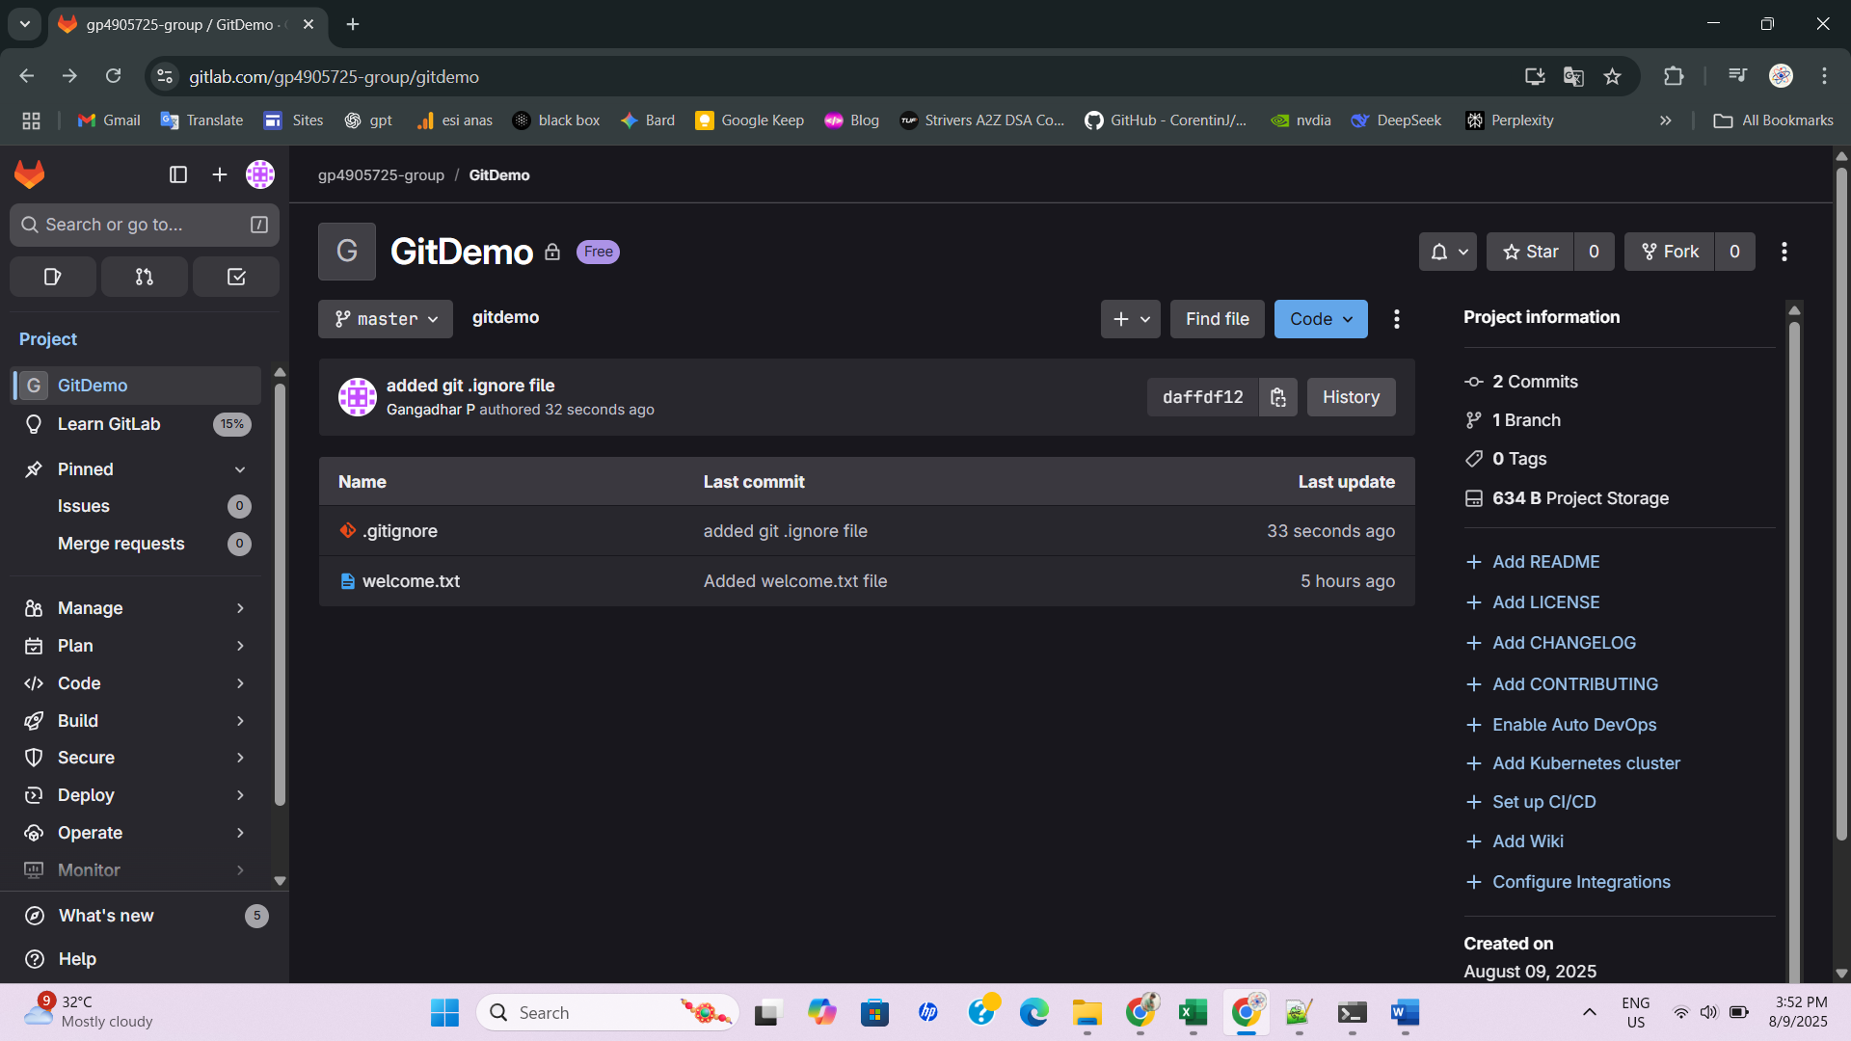

**Solution 3:**

I created the new branch using this command “**git branch GitNewBranch**”

And I list all branches using the command **“git branch -a”**

I switch the new branch from the current master branch using the command **“Switch to the new branch”**

And i added the files in the newbranch

echo "This is a test file for GitNewBranch" > branchfile.txt

git add branchfile.txt

git commit -m "Added branchfile.txt in GitNewBranch"

After that i checked the status of the git using  **“git status”**

**Merging the branches:**

Now Im switch the new branch to master branch using the command “**git checkout master**”

I show command-line differences between master and GitNewBranch using command “**git diff master GitNewBranch”**

After i merge branch into master using the command “**git merge GitNewBranch”**

When i want to see the merge history using the command **“git log --oneline --graph --decorate”**

Delete the branch after merge using the command “**git branch -d GitNewBranch**”

Now verify the status of the git using the command “**git status”**

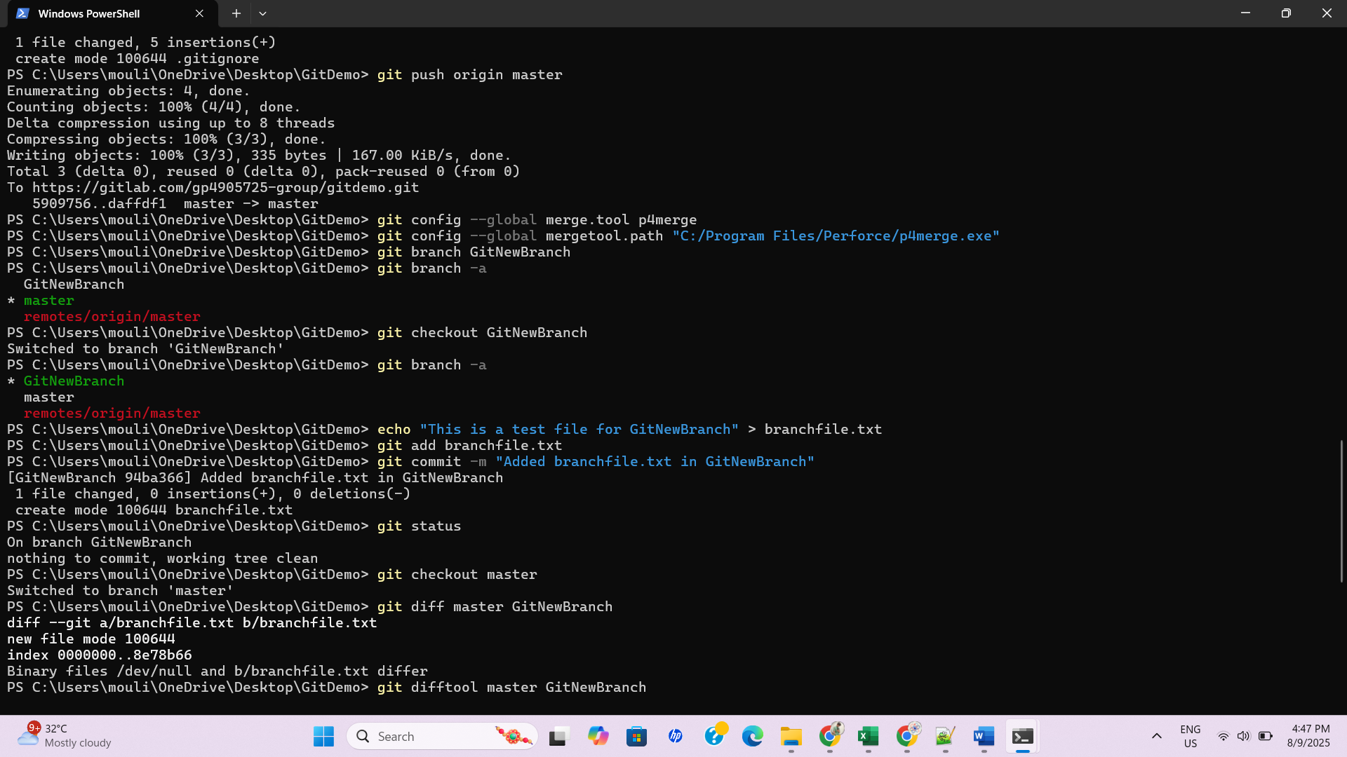

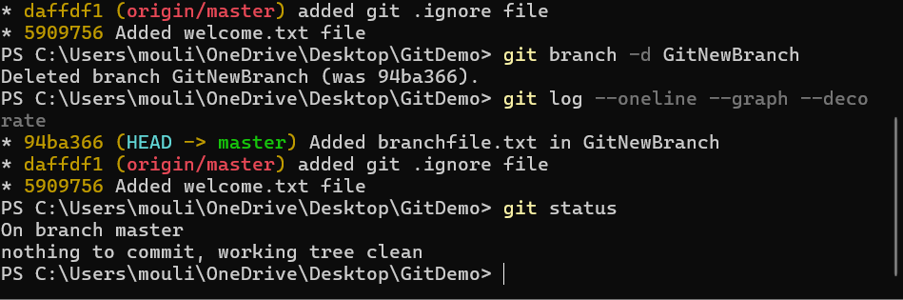

I created the merge request and merged successfully

